**Cloud Storage:**

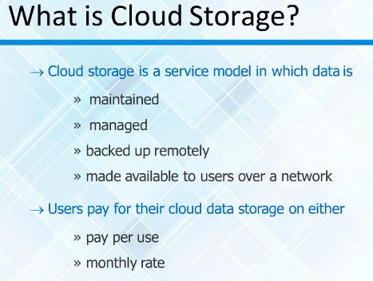

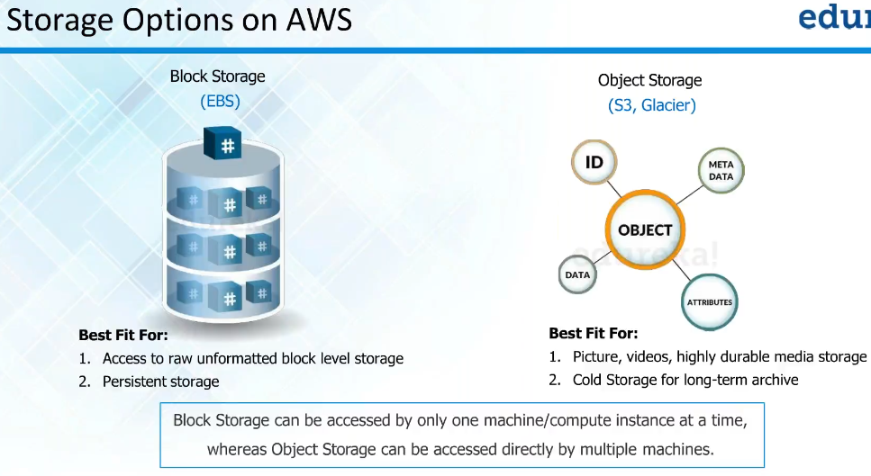

**Two types of storage:**

1. Block storage and
2. Object storage

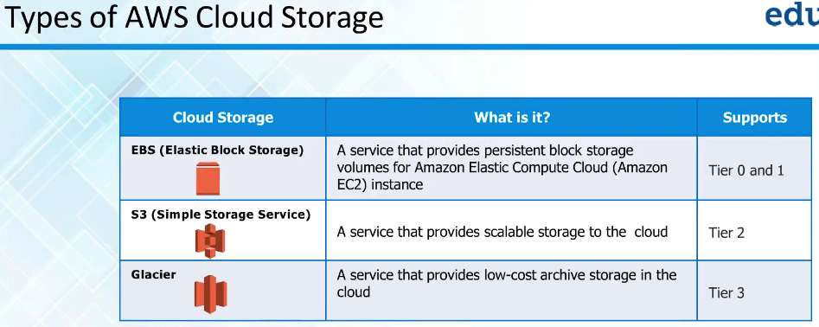

* Block storage means EBS, object storage is S3 and glacier is archival storage for long term
* EBS is high cost and high performance
* S3 also high performance. But we can’t use it for installing applications and databases. We can only store files on this
* Glacier is slow

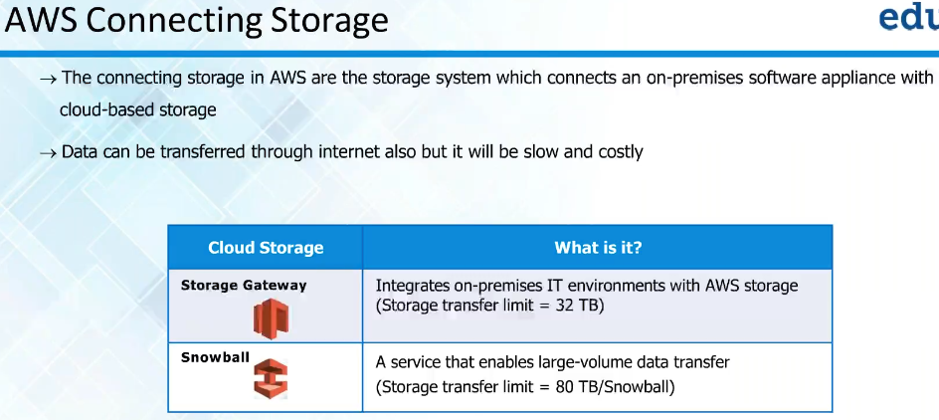

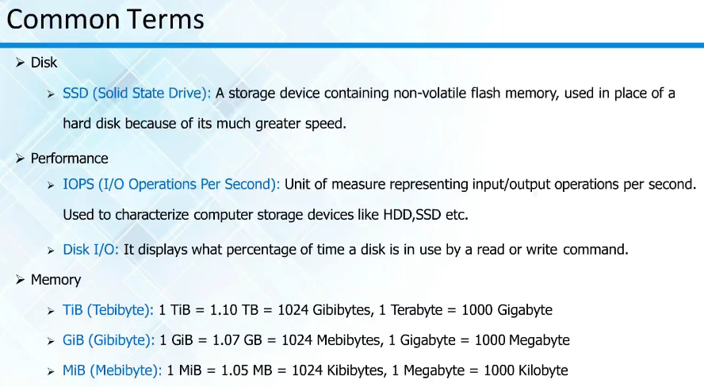

* SSD offers great performance
* IOPS means how many read/write operations per second. The more operations are, the faster device is

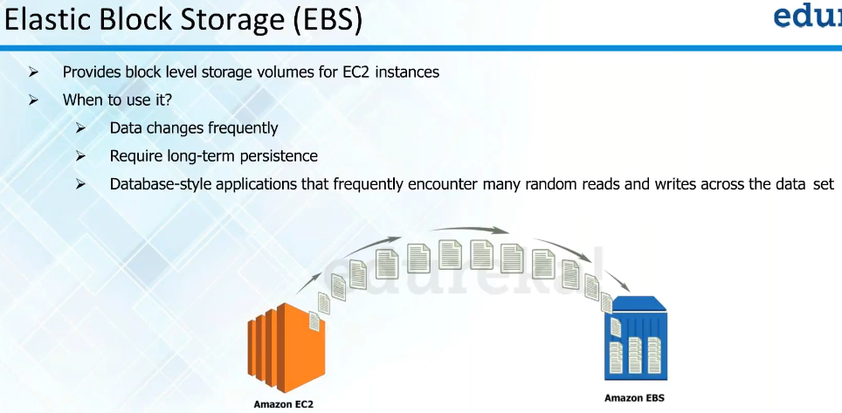

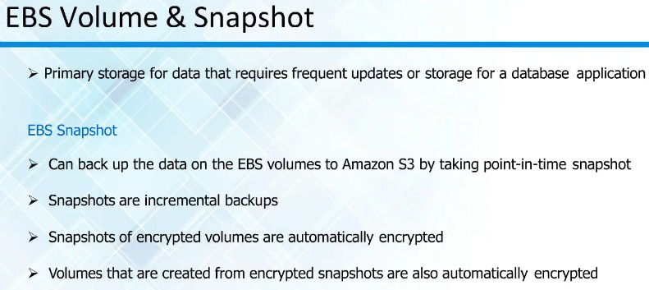

**EBS (Elastic Block Storage):**

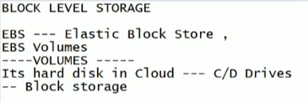

* Entire storage divided into two parts, one is block storage and another is file storage
* Volumes are nothing but drives
* Block storage, we make it into smaller pieces called volumes

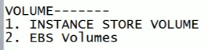

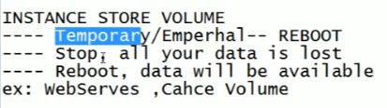

* Instance store volumes are temporary. It will be available if we reboot
* If we stop it. The data will be lost
* These are the cheaper versions of block storage

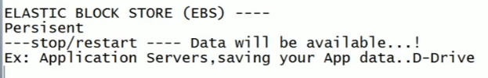

* EBS can be detached whereas ISV cannot be

**Introduction:**

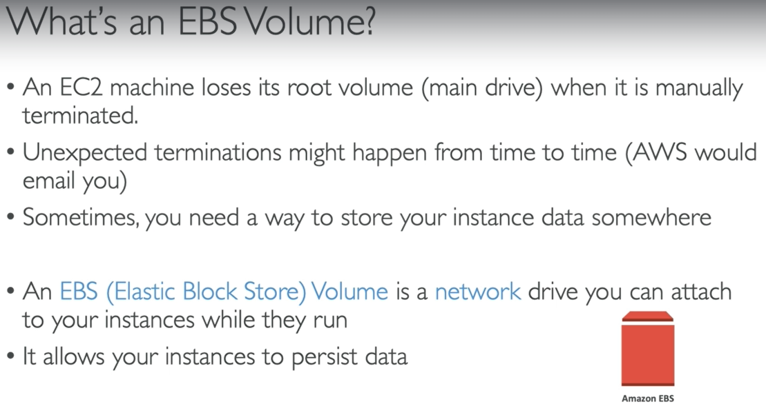

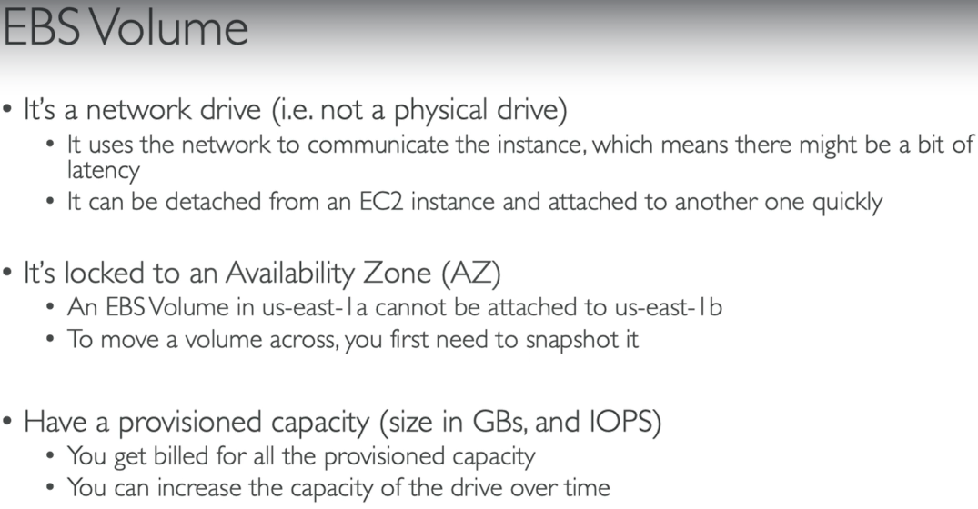

**We can use EBS volumes only in availability zone. We can’t detatch it from AZ and attach it to other.**

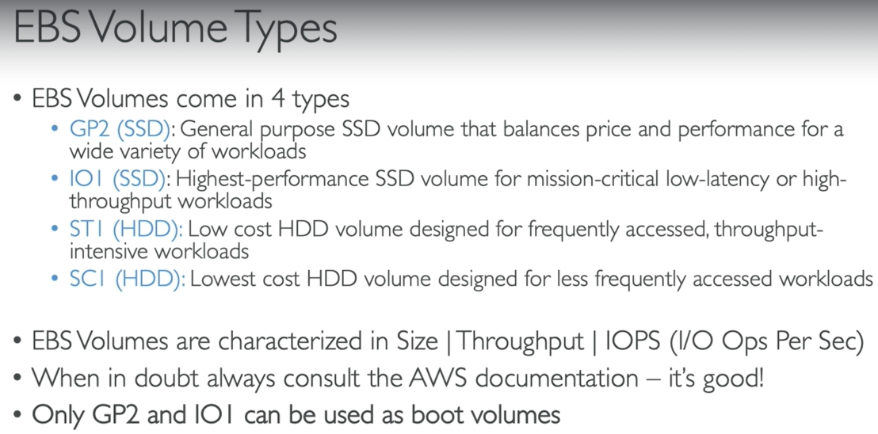

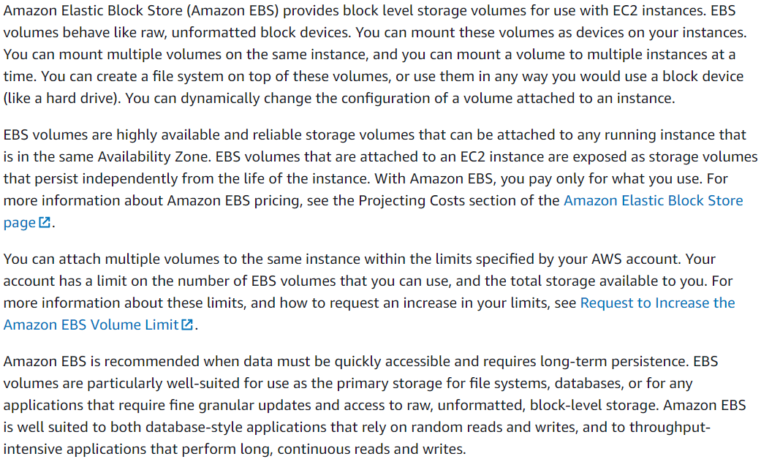

**Features:**

